DEALS TO VANCOUVER, WA

Situated just across the Columbia River from Portland, Vancouver is a lush city best experienced outside. From the thousands of acres of public parks to airy public markets, there’s plenty to enjoy in the fresh Pacific Northwest air. Book a trip to Vancouver, WA via Portland International Airport on Virgin America. Live it up at 35,000 feet with WiFi, on-demand entertainment, and more on every flight.

(MARKET IMAGE HERE)

Find Deals From These Cities

INSERT FARE GRID FROM / TO Version (if available!)

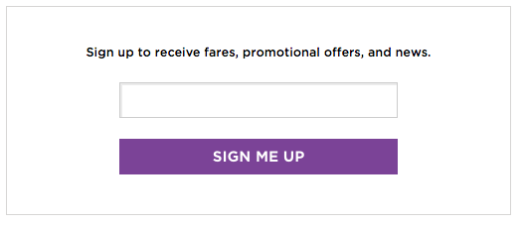   
Top Things To Do in Vancouver, WA

To get you started, check out these activities in Vancouver, WA when planning your trip.

* Take a day trip to the Columbia River Gorge, a breathtaking 70-mile stretch cutting through the Cascade Mountains. Stop at any of the famous waterfalls including Bridal Veil Falls, Wahkeena Falls or Latourell Falls for a cool mist and great photo ops.
* Visit the Pearson Air Museum, a National Historic Site that started as a civilian airfield where pilots performed aerial acrobatics and tricks, then became a production facility for wooden aircrafts. After decommission from the Army Air Corps it became a fascinating museum.
* There’s no shortage of fresh seafood options in Vancouver. Check out Beaches or Quay Restaurant & Bar for beautiful views across the Columbia while you dine. Want to cook up your own fresh catch? Locals know the Ocean King Market is the place for live shrimp, lobster and clams.

Travel Tips and Resources

[Must-Dos in Vancouver](https://www.tripadvisor.com/Tourism-g60820-Vancouver_Washington-Vacations.html)

[Vancouver Hotelshttp://www.tripadvisor.com/Hotels-g60820-Vancouver_Washington-Hotels.html](http://www.tripadvisor.com/Hotels-g60820-Vancouver_Washington-Hotels.html)

[Vancouver Restaurantshttp://www.tripadvisor.com/Restaurants-g60820-Vancouver_Washington.html](http://www.tripadvisor.com/Restaurants-g60820-Vancouver_Washington.html)

[Vancouver Shopping Guidehttp://www.visitvancouverusa.com/things-to-do/shopping](http://www.visitvancouverusa.com/things-to-do/shopping)

[Vancouver Nightlife and Entertainment](http://www.visitvancouverusa.com/things-to-do/nightlife)

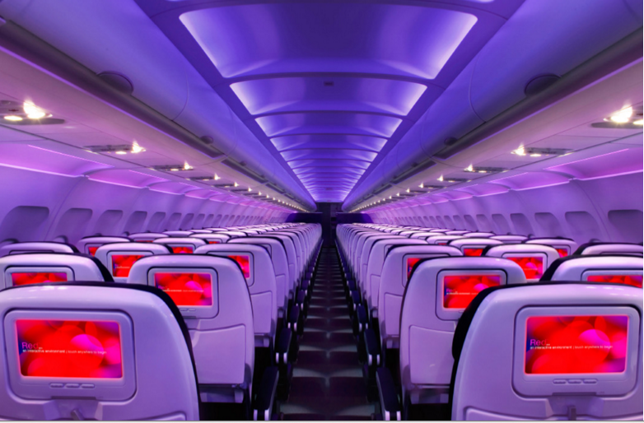

Main Cabin Main Cabin Select First Class

(add links to Cabin Class Pages)

Ready. Set. Fly.

Book your Mood-lit Ride to Vancouver, WA.

If you’ll be traveling to Vancouver, consider booking a flight with Virgin America to Portland International Airport. You’ll enjoy plenty of inflight amenities, such as our in-seat entertainment, on demand food ordering, amazingly comfortable leather seats, and much more. Flying with us is an experience like no other.

Take a Virtual Tour

Add Terms & Conditions